MILESTONE ACADEMY
VACATION HOME WORK
CLASS- VI
PC/MS/2019-20/VI/048
----------------------------------------------------------------------------------------------------------------------------------------------------------
ENGLISH-
- Write an essay of not more than 200 words on the following topic “A day in your life as a policeman”.
- Write a letter to a friend who has failed in the final examination advising him/her not to give up hope
and try once again.
- Cross Word Puzzle:-

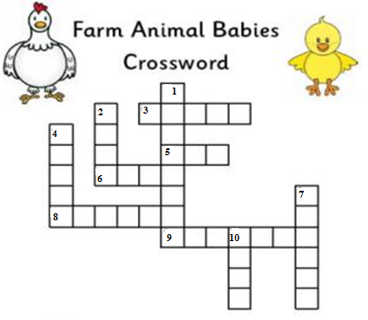

Across Down
3. A baby dog 1. A baby duck
5. A baby goat 2. A baby cow
6. A baby horse 4. A baby hen
8. A baby cat 7. A baby pig
9. A baby goose 10. A baby sheep

GSC-
I) Design an Emergency Light for your home by using materials like LED light, Battery, Plastic Bottle , wires etc.
II) Chart Making – Make a study and Enlist the various vitamins present in fruits and vegetable that you eat.

PTO

MATHS-
Make a project file –1. Write 10 lines about Ramanujan and Euclid.
2. Describe Polygon and explain each type of Polygon and also paste the figures of each
type of Polygon.
S.SC-
1. Paste the pictures of 6 flags of different countries that have hosted Asian Games and mention the reason behind
why the flag was designed and message behind it.
2. Collect information about the artificial satellites launched in India. Find out how they help us in the field of
communication and weather forecasting. (Paste the pictures in chart paper and write about them.)
HINDI- 1- ^ oSHko vyekjh * ds fy, vkd"kZd foKkiu fyf[k,A
2- ^isVªksy dh cpr* fo’k; ij vuqPNsn fyf[k,A

SANSKRIT- 1. dkjd jpuk – jke] yrk] Qy
2. /kkrq:ikf.k – ik ] n`'k~ ] LFkk
3. vO;; 'kCn – v/k%] “o% ] izkr%] lk;e~] p] vfi] lg] ;=] r=] g~;%
4. la[;k 'kCnk% & 11 ls 20
COMPUTER-
Make a Power Point presentation on Lesson No. 10 Internet Services and submit Hard copy
1. Brief History of Internet 2.Popular Services on the Internet
---------------------------------------------------------------------------------------------------------------------------------------------
LIFE SKILLS
This activity is surely going to help students identify and enhance the skills to find creative and constructive solution to the problems and issues. List/describe (in a sentence or two each) some consequences.
- What if each home could run the T.V. only one hour a day?
- What if petrol grew on trees and was a renewable resource?
- What if exams were abolished in colleges as well?
- What if our pets could talk?
- What if clock and watches didn’t exist and day light lasted six months?

SUBMISSION DATE- 31/10/19

190

